Professor: Chuck Bland

EE 375 Section 02

12:10 - 3:00 PM Tuesday

Lab #4

Written By:  
John Gharib

Aria Amini

Austin Ma

May 10, 2021

Part I - Open Stub Simulation

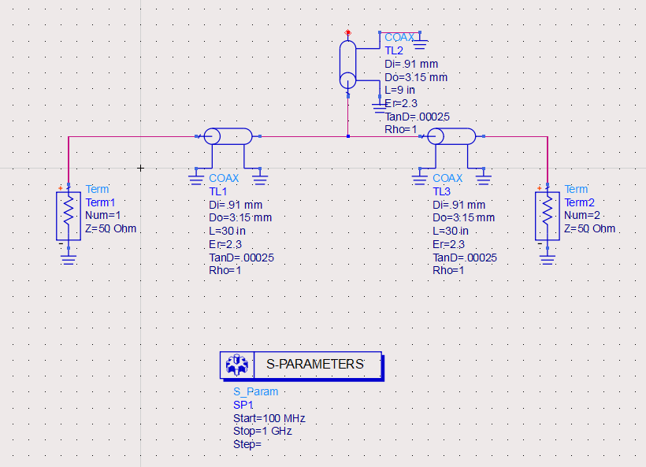

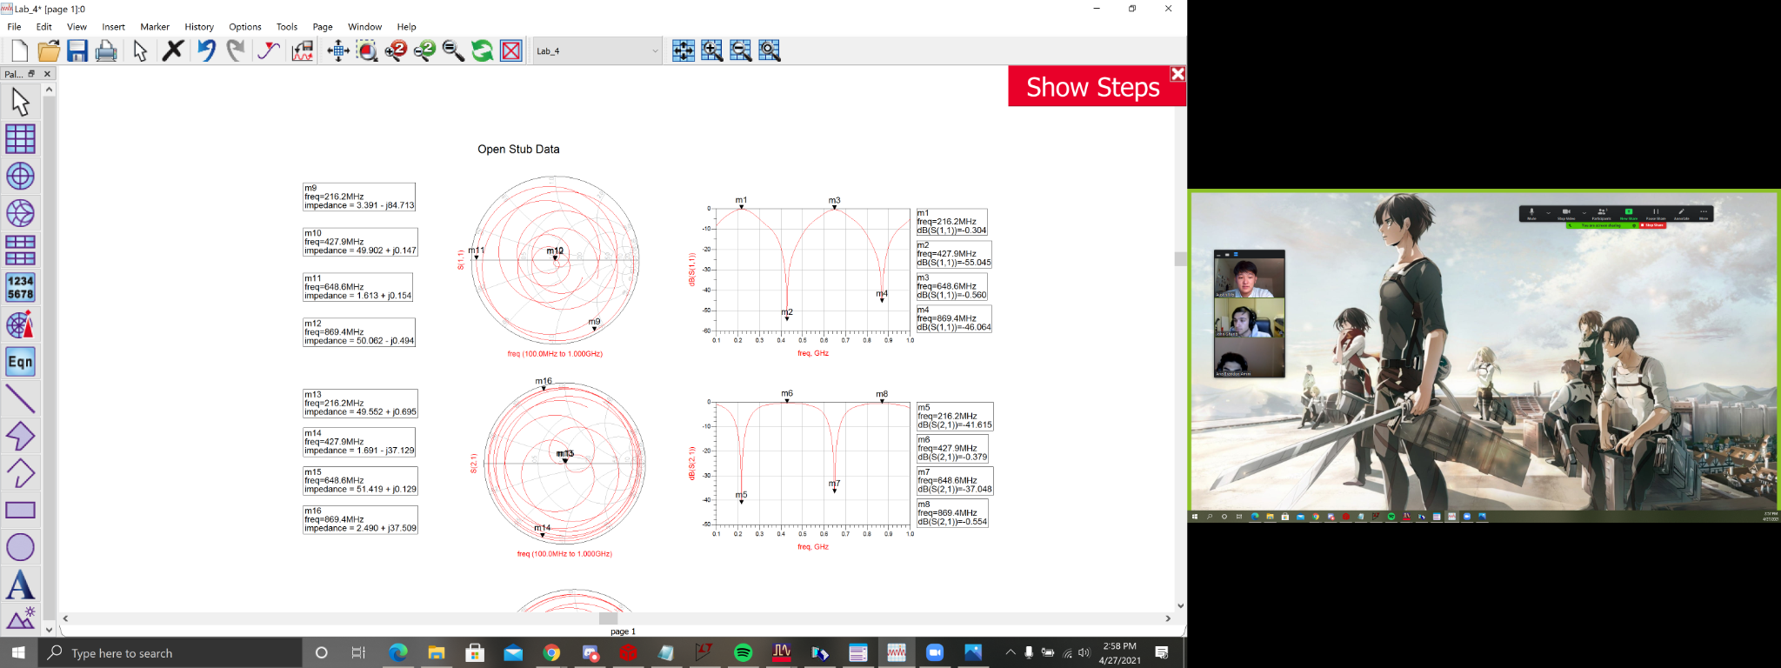

5.

If Vp = 2.998E8 m/s and VF = 0.66, then Vp = 1.978E8 m/s

Coax half Wavelength - in,

Coax quarter Wavelength - in,

8a. The markers between M2, 4, 5, and 7 don’t completely align as the simulation has a higher resolution in calculating the exact frequency notched out compared to our hand calculations (which use rounded parameters, like the velocity factor and speed).

At markers M2, 4, 5, and 7 the stub is filtering out signals at those specifically marked frequencies.

8b. I /II. M2 and M4 are the frequencies that respectively correspond to half and the full wavelengths of the open stub, which are the frequencies when the stub is seen as an open. In this situation, almost all of the energy is passed onto the load, so the values of S(1,1), the reflection coefficient seen at the source, are at a minimum at these points.

8c. I/II. M1 and M3 are the frequencies that respectively correspond to the quarter and three-quarters wavelengths of the open stub, so the stub is seen as a short to ground. When this happens, little to none of the energy is passed to the load, but is instead reflected back to the source, so on the values of S(1,1), the reflection coefficient seen at the source, are at a maximum at these points.

8b. III/IV. M5 and M7 are the frequencies that correspond to the quarter and three-quarters wavelengths of the open stub, so the stub is seen as a short to ground. When this happens, little to none of the energy is passed to the load, so on the plot of S(2,1), the transmission coefficient from the source to the load, the points are at a minimum because little to no energy is transferred to the load.

8c. III/ IV. M6 and M8 are the frequencies that respectively correspond to half and the full wavelength of the open stub, which are the frequencies when the stub is seen as an open. In this situation, almost all of the energy is passed onto the load, so the plot of S(2,1), the transmission coefficient from the source to the load, is at a maximum at these points.

10. If the peak of S(1,1) ( M1 ) is the power reflected back to the source, that means on S(2,1) it must thus be at the same frequency that M5 is at the minimum since all the power is reflected, very little to none must then go to the load.

13a. The impedances at each of the Smith Chart markers are the impedances of the transmission lines as seen by the source varying with frequency.

M9: M9 is the equivalent input impedance seen by the source at the frequency corresponding to ¼ λ of the open stub, which is seen as equivalently being shorted to ground.

M10: M10 is the equivalent input impedance seen by the source at the frequency corresponding to ½ λ of the open stub. The impedance seen is the same as the characteristic impedance of the line, and the signal is passed through at maximum amplitude

M11: M11 is the equivalent input impedance seen by the source at the frequency corresponding to ¾ λ of the open stub, which is seen as equivalently being shorted to ground.

M12: M12 is the equivalent input impedance seen by the source at the frequency corresponding to the full λ of the open stub. The impedance seen is the same as the characteristic impedance of the line, and the signal is passed through at maximum amplitude

M13 - M16: While there are impedance values for M13 through M16 on the smith chart, they do not have meaningful value because on the Smith Chart, they are a measure of the gain/ loss through the transmission network

13b. A quarter wave open stub can operate as a notch filter because at the ¼ wavelengths of a specific frequency, the stub’s voltage increases as the current decreases from start to finish becoming just an open at the end of the stub and letting no signal leave.

13c. And at half-wave frequency, 432MHz, the stub has maximum power transfer because there is little to no reflected voltage and almost fully transmitted voltage.

13d. Since coax 2 and coax 3 both lead to ground at the ends of each other and share the same node at the beginning, they’re thus in parallel.

13e. At the frequency corresponding to ¼ λ of the stub, the impedance seen at the source is largely capacitive because the current is leading the voltage by 90 degrees, as depicted

Max power transfer at half wavelength

Filter at quarter wavelength

Part II - Shorted Stub Simulation

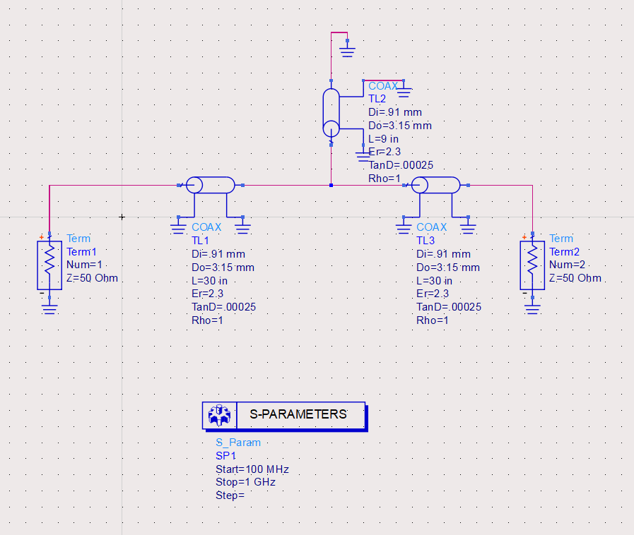

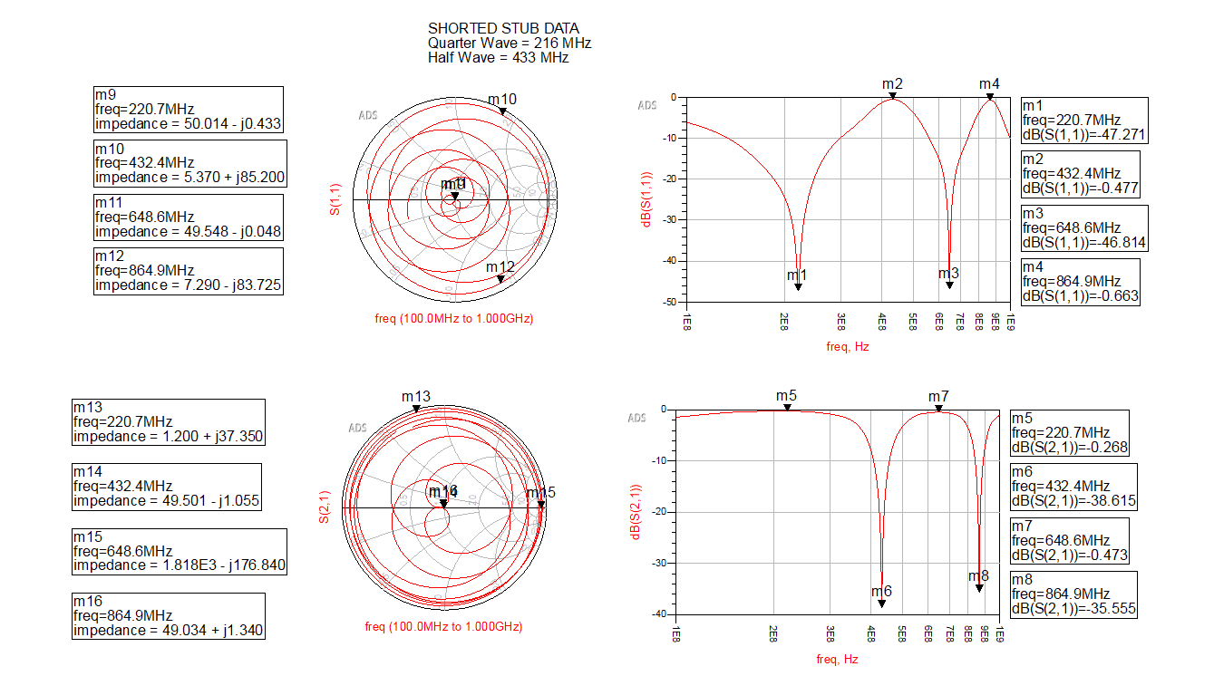

21.

1. 1. M1 is the ¼ 𝜆 reflected energy seen by the source
   2. M3 is the ¾ 𝜆 reflected energy seen by the source
   3. M6 is the ¼ 𝜆 transmitted energy seen by the load
   4. M8 is the ¾ 𝜆 transmitted energy seen by the load
2. 1. M2 is the ½ 𝜆 reflected energy seen by the source
   2. M4 is the full 𝜆 reflected energy seen by the source
   3. M5 is the ½ 𝜆 transmitted energy seen by the load
   4. M7 is the full 𝜆 transmitted energy seen by the load

23. M1 defines the same frequency for M5 since they’re both at the frequency that corresponds to ¼ λ of the shorted stub.

26.

M9: M9 is the equivalent input impedance seen by the loadat the frequency corresponding to ¼ λ of the shorted stub, which is seen as equivalently being shorted to ground.

M10: M10 is the equivalent input impedance seen by the load at the frequency corresponding to ½ λ of the shorted stub, which is seen as equivalently being left as an open.

M11: M11 is the equivalent input impedance seen by the load at the frequency corresponding to ¾ λ of the shorted stub, which is seen as equivalently being shorted to ground.

M12: M12 is the equivalent input impedance seen by the load at the frequency corresponding to the full λ of the shorted stub, which is seen as equivalently being left as an open.

M13 - M16: While there are impedance values for M13 through M16 that can be extracted from the smith chart for S(2,1), they do not have any significant meaning because S(2,1) is the transmission coefficient, which is how much gain/ loss there is in the transmission network.

Part III - Simulation Data Analysis

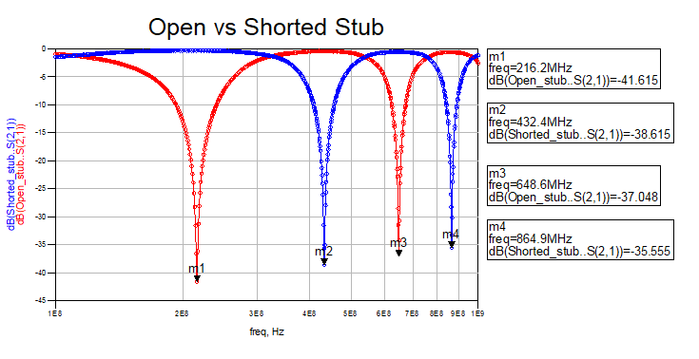

Questions

Open Stub Questions:

1. Open stub quarter wave notch frequency (216.2MHz) vs calculated open stub quarter wave notch frequency (216.4MHz),
   1. A potential source of error is our hand calculations not accounting for the attenuation constant, , while our simulations did (thus, the simulation accounts slightly more realistically, how truly not lossless TL lines are in theory)
2. At odd multiples of the ¼ wave frequency of the ¼ wave stub, the stub exhibits a narrow band reject filter behavior since it rejects frequencies within a really narrow range as it acts as a short, while even multiples of the ¼ wavelength frequency of the open ¼ wave stub acts as an open and exhibits periodic bandpass behavior.
   1. A potential source of error is our hand calculations not accounting for the attenuation constant, , while our simulations did (thus, the simulation accounts slightly more realistically, how truly not lossless TL lines are in theory)

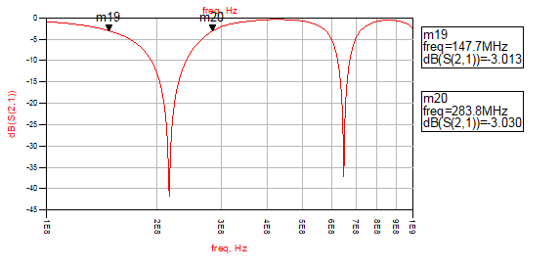

From the figure above:



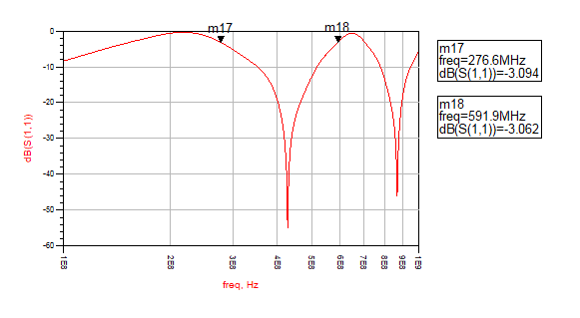

From the figure above:

Shorted Stub Questions:

1. Quarter wave frequency of the pass peak (M5) is 220.7 MHz, and the calculated quarter wave frequency is 216.4MHz,
   1. A potential source of error is our hand calculations not accounting for the attenuation constant, , while our simulations did (thus, the simulation accounts slightly more realistically, how truly not lossless TL lines are in theory)
2. Half-wave frequency of the pass peak (M7) is 648.6MHz and the calculated half-wave frequency is 649.2MHz,
   1. A potential source of error is our hand calculations not accounting for the attenuation constant, , while our simulations did (thus, the simulation accounts slightly more realistically, how truly not lossless TL lines are in theory)
3. Like the open stub, the shorted stub exhibits seemingly periodic bandpass regions, however, also exhibits periodic narrow regions of band reject behavior due to the odd multiples of the ¼ 𝜆 frequencies making the stub act as an open (letting all the signal pass to the load) and the even multiples of the ¼ 𝜆 frequencies making the stub act as a short (letting little power from the source transmit to the load) for a very narrow range of frequencies.

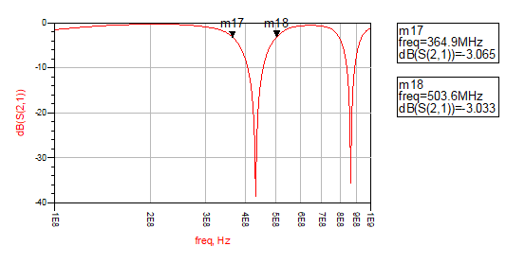

From the figure above:



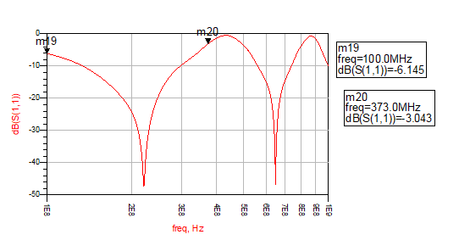

From the figure above:

Open vs Shorted Stub Questions:

1. It looks like the band reject behavior of each stub had interfered with each other and dipped (naturally like notch filters) into each other’s bandpass regions, making this extra bumpy graph with more dipping magnitudes.
   1. 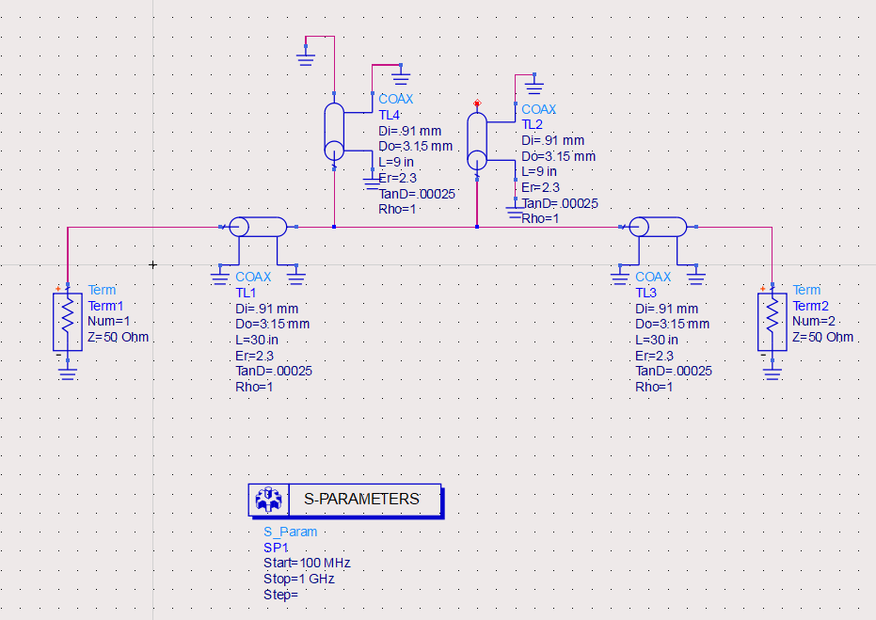

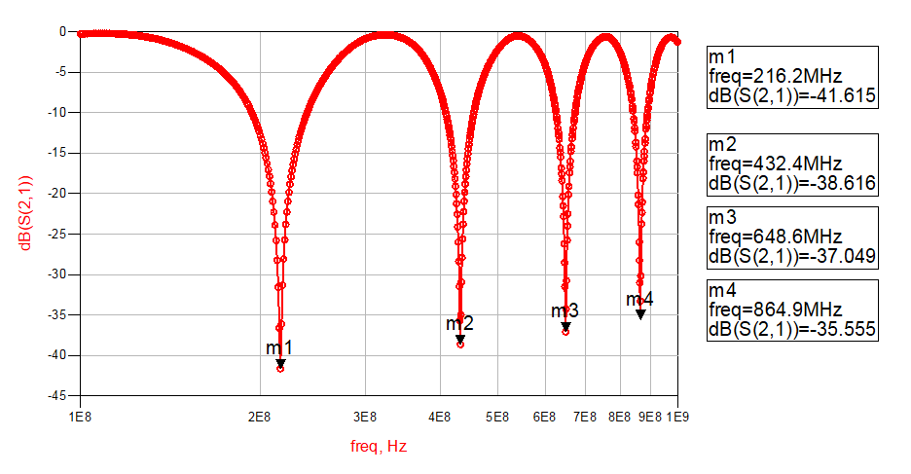

The four dips are at the same frequencies as the dips in the composite Open Stub vs. Shorted Stub graph from Part III.

* 1. The four dips are created by the parallel combination of the open and shorted stub. The low pass behavior of the shorted stub and the notch behavior of the open stub add together to create the composite frequency response shown above.

Designing a composite filter to allow more narrow frequency ranges to be accepted while more broad frequency ranges to be rejected, seems to work better when different lengths of stubs are attached in series to each other rather in parallel as we did with the open and short stub simulation. This “better” composite comb filter is seen in the figures below.

